**QE Tasks**

1. Take Sonar Status on daily basis and save the screenshot in the below location

**Location to save sonar Status:** \\dwdf210\sls\LP\QualityManagement\SonarStatus

**Sonar Link:** <https://ldisonarci.wdf.sap.corp:8443/sonar/dashboard/index/306236>

1. Monitor Q-KPIs
2. Verify the Test build status in Jenkins and check the same status is updated in GTP

**Jenkins**

* Login to Jenkins

**Link:**

<http://mo-543f0fc82.mo.sap.corp:8080/jenkins/view/Codeline%20STH%20Master/>

ID/Password: C User ID & Respective Password

* Go to Translation_Service 🡪 Translation_Service_IntTests

Left Hand side of the screen there will be build history. Latest will be on top, we can check the build status. If build is successful it will be in green color and if it is not then it will be in red color

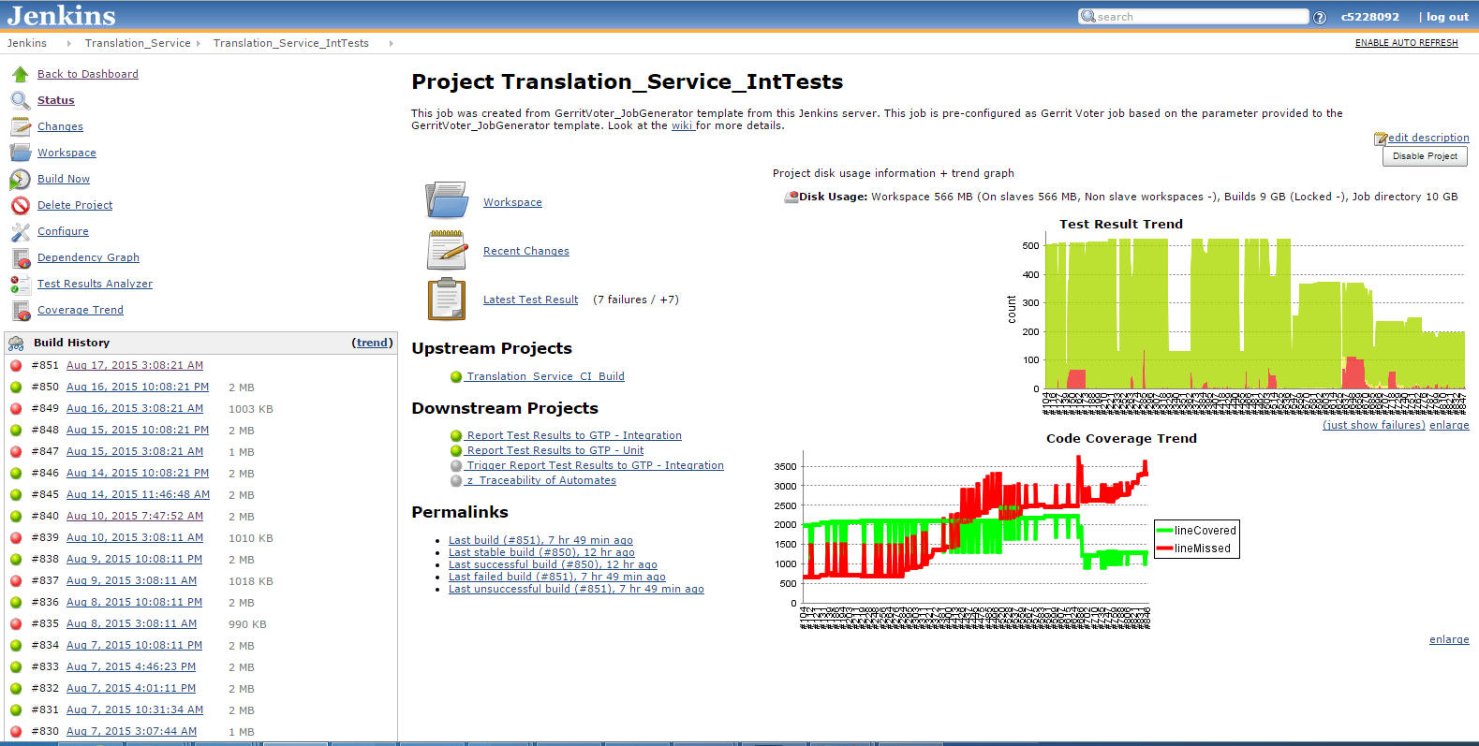

* In order to see the failure result: click on the latest build. It gives the list of failures.

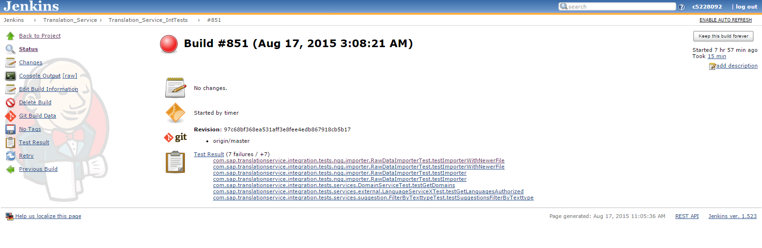

* Verify the reason for failure by clicking on the items listed in the above screen

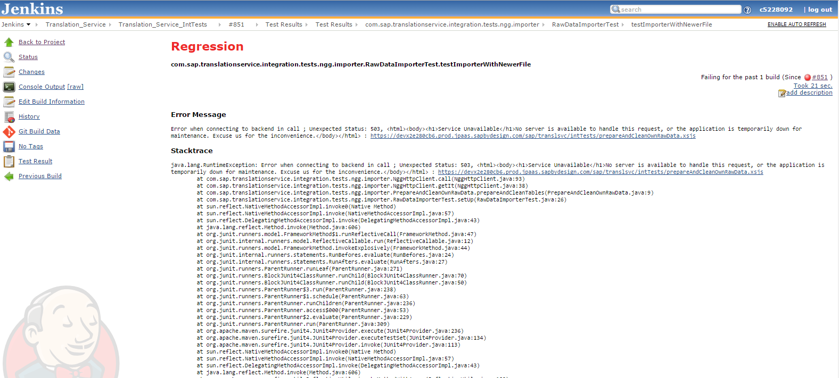

* Jenkins job for updating the respective test results in GTP should be run successfully.

Report Test Results to GTP - Integration

**Verify that the errors logged in GTP is same as that in Jenkins.**

Steps:

* Go to SAP Logon. First Time User add GTP details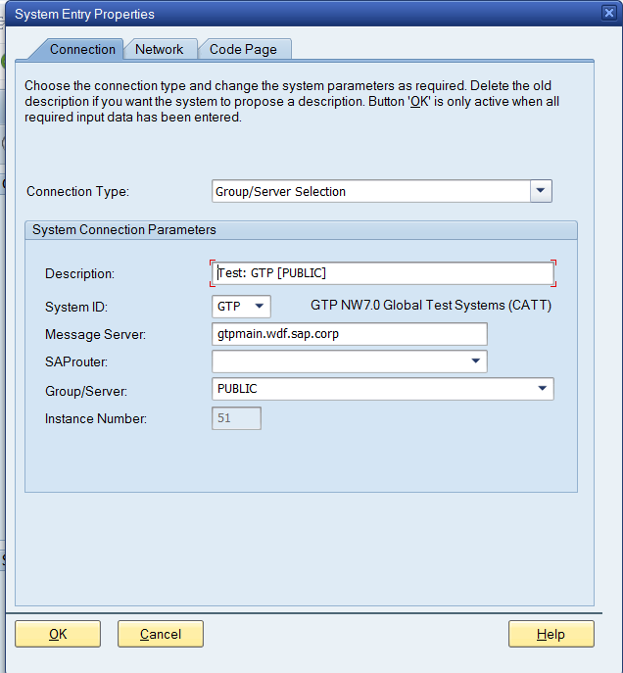

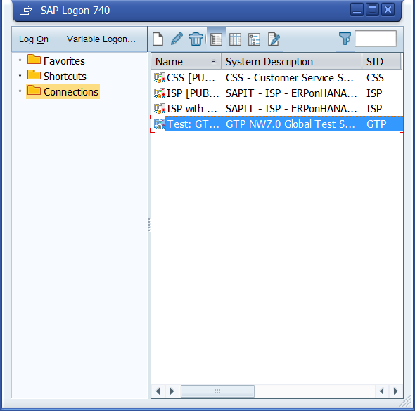

* Double click on GTP

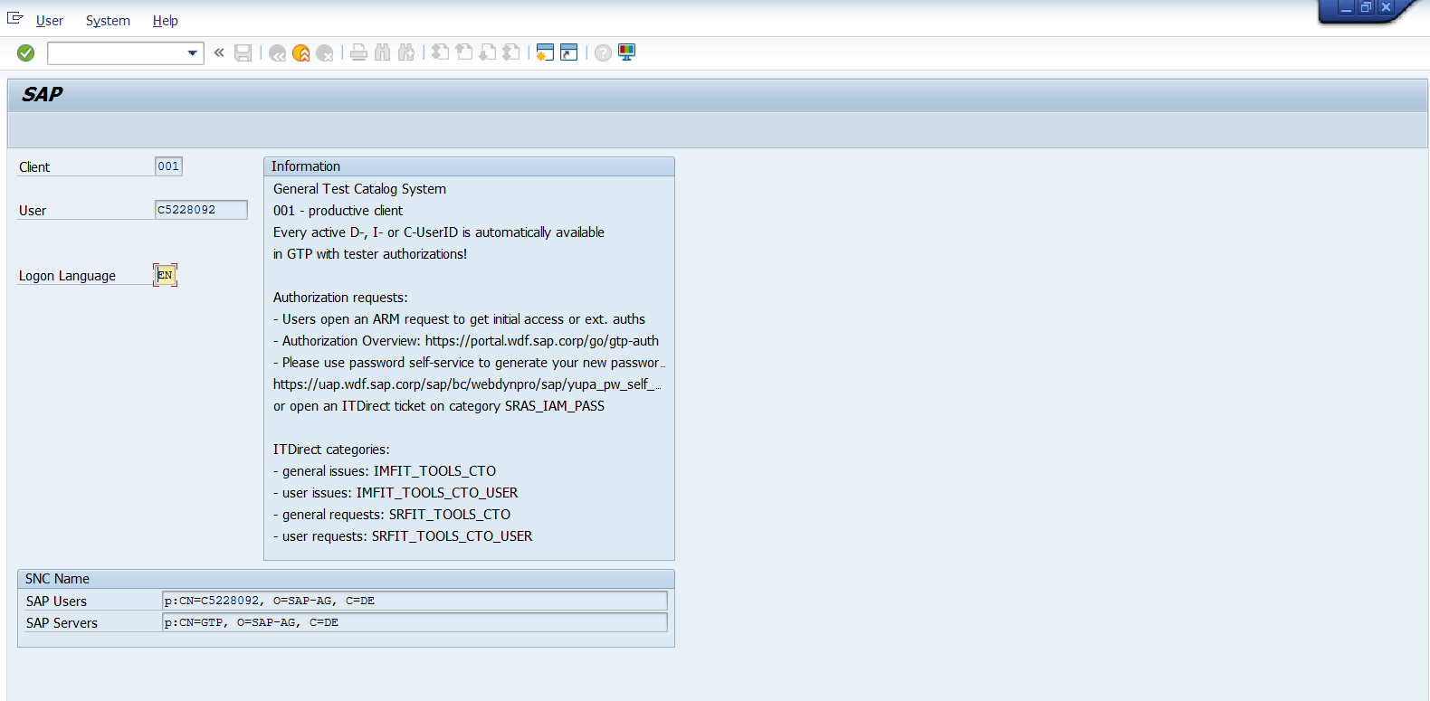

* Login in using the single sign on for your C User ID and search for /nstwb_info

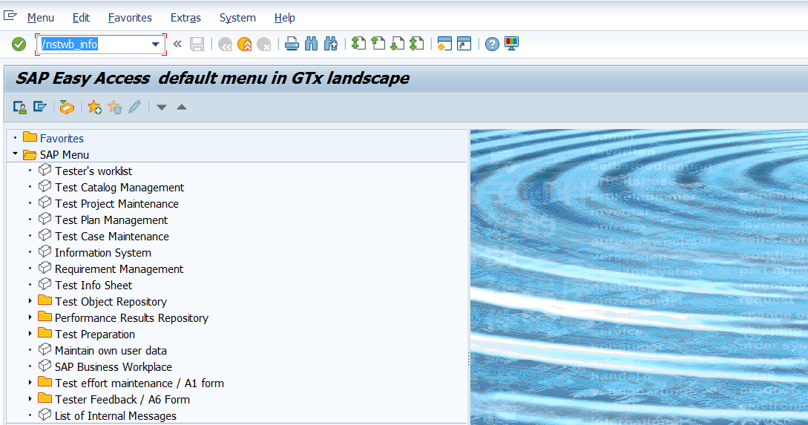

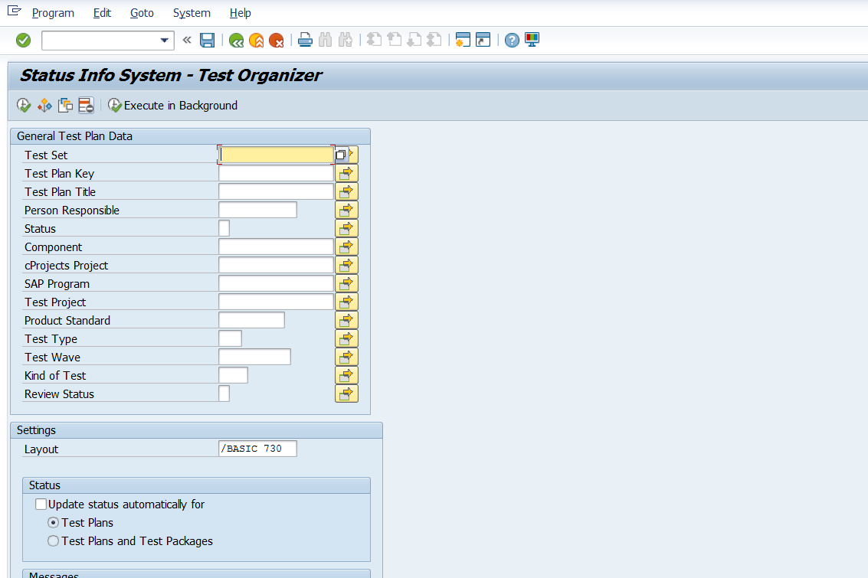

* Under Find Variant search with Created By as “Kerstin User ID”

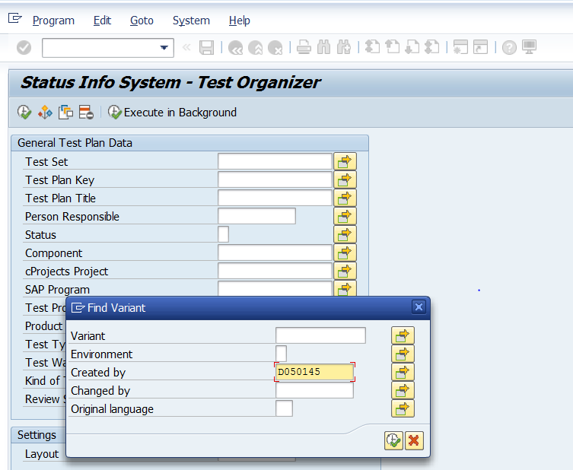

* Select Translation Hub project

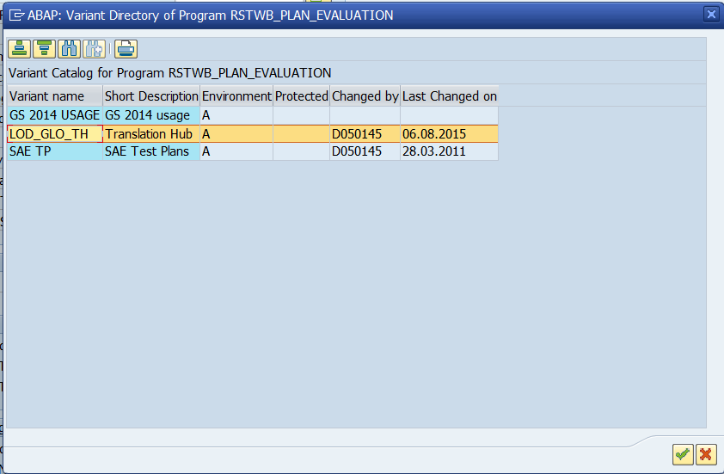

* Layout select “Basic 730” and under test plan title give “*08a” and execute

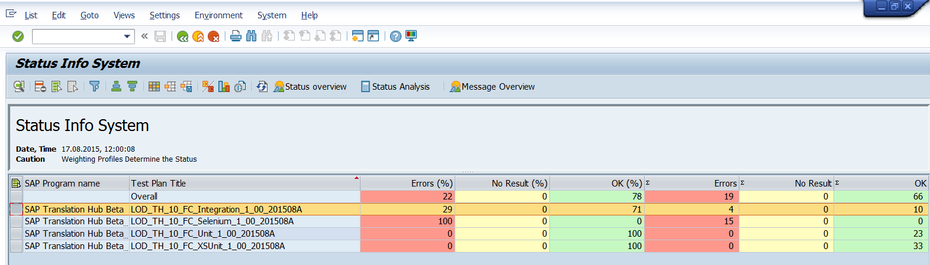

* Select Integration Test and click on status analysis to verify if the errors are same as the one in Jenkins

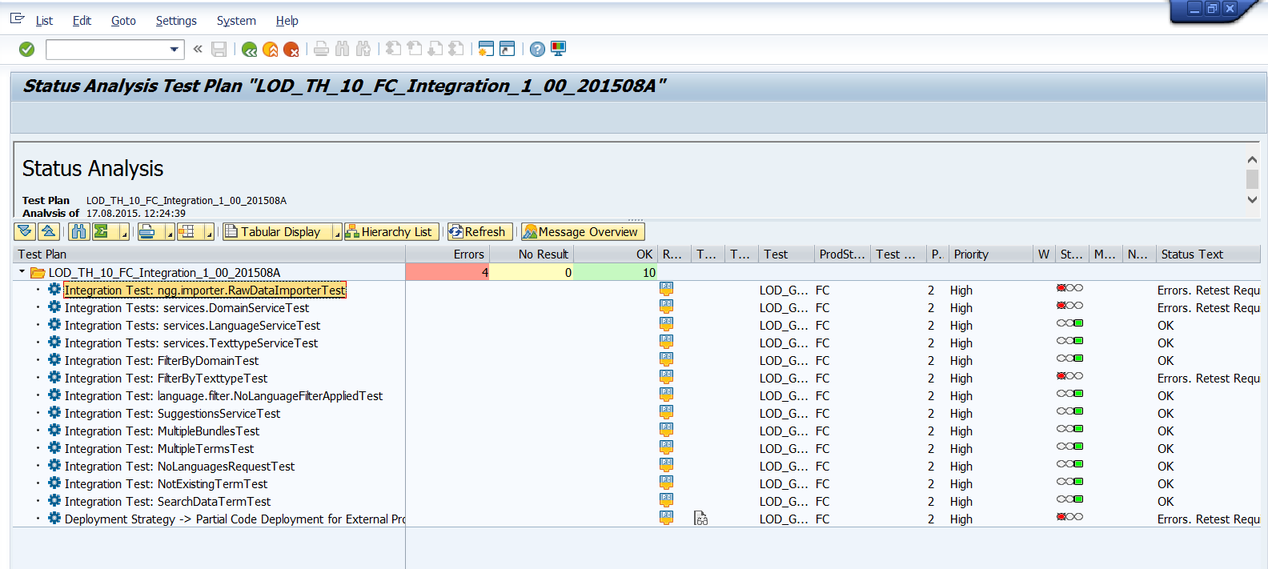

**Note:** Similarly we need to verify for all the tests results listed in GTP with respect to Jenkins

1. Verify the Fortify Job has run successfully or not, if not the reason for failure and the fix
2. Verify the Sonar Job has run successfully or not, if not the reason for failure and the fix